Name:  Click or tap here to enter text. | Date:  Click or tap to enter a date.
We have briefly mentioned the complimentary behavior of capacitors and inductors. Recall the impedances of the two devices are purely imaginary and are given by:
$$Z_{C}=-j\frac{1}{ωC}$$ | $$Z_{L}=jωL$$
The impedances of the two devices are complementary in two senses:
- the impedance of one device falls with frequency (true of $Z_{C}$), while the other rises with frequency (true of $Z_{L}$);
- the phase shifts between current and voltage are opposite for the two devices, as is indicated by the opposed signs of $-j$ and $j$. Current leads voltage in the capacitor; it lags voltage in the inductor.
You could use $L$ or $C$ equally well to make a filter. Below, for example, are two versions of a low-pass filter.
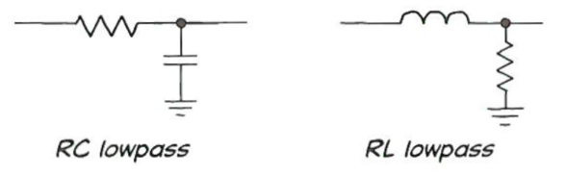
Both versions of the low-pass filter work. But only the $RC$ is practical, at all but very high frequencies.
Capacitors are used much more widely than inductors. The difference comes from the fact that inductors are relatively large and heavy (often including a core made of iron or another magnetically-permeable material), and that, owing to departures from ideal, they dissipate power.
That difference leads one to prefer capacitors and to avoid inductors altogether except at high frequencies; perhaps 1 MHz, or more, where a small value of inductance is sufficient to do the job.

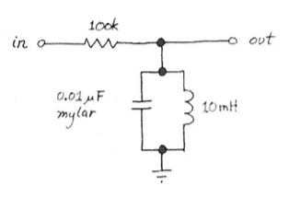
Resonance
The adjacent figure shows the resonant $RLC$ circuit that we will study in this lab. Before we acknowledge what's novel about this circuit—its resonance—let's take advantage of what we know of the impedances of capacitors and inductors to make a simple argument that this is a bandpass filter: one that passes a range of intermediate frequencies, while attenuating both frequency extremes.
If we neglect the effect of the inductor (below left) we see a familiar RC low-pass filter. At high frequencies, it is fair to neglect the parallel inductor: its impedance is much larger than the impedance of the capacitor.
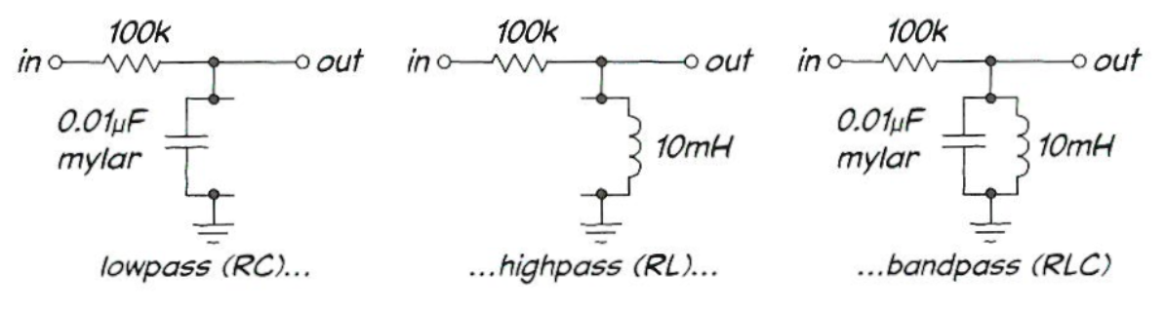
Toward the other end of the frequency range, the inductor’s impedance is much less than that of the capacitor (recall that $Z_{L}=jωL=j2πfL$). In this frequency range, the $RL$ forms a high-pass filter (above middle). Over the full frequency range, then, the $RLC$ forms a bandpass filter (above right).
But that analysis misses the interesting novelty of this circuit: the "resonance" to which we have referred. At some frequency, where the magnitude of the impedances of inductor and capacitor are equal, something startling occurs: the impedance of the parallel $LC$ becomes very large.
This is easy to see if you write out the formula for the impedance of the parallel combination of the inductor and capacitor pair,
$$Z_{C}∥Z_{L}=\frac{Z_{C} Z_{L}}{Z_{C}+Z_{L}}.$$
Because $Z_{C}=-j/ωC$, while $Z_{L}=jωL$, the opposite signs of the $j$ indicate that at some frequency, where the magnitudes are equal, the two impedances should sum to zero. When this occurs, taking the denominator of the parallel impedance to zero, the parallel impedance "blows up" or becomes very large. You may want to say that the parallel impedance would become infinite, but imperfections—largely caused by resistance and core losses in the inductor—spoil this result. But it is enough that the impedance becomes very large and is extremely sensitive to small frequency changes.

Derive and equation for the resonance frequency $f_{r}$.
Compute the theoretical expression for the resonance frequency of the $RLC$ Circuit that you will build in lab this week in terms of the capacitance $C$ and inductance $L$. To do so you will want to force the denominator of the expression for the parallel impedance of $L$ and $C$ to be zero, solve first for the angular frequency $ω$ and then solve for the frequency $f$ using $ω=2πf$.
Click or tap here to enter text.

Compute the numerical value of the resonance frequency $f_{r}$.
Compute the numerical value resonance frequency of the $RLC$ Circuit that you will build in lab this week. Use component values of $L=10$mH and $C=0.01$µF as shown in the circuit diagram above.
Click or tap here to enter text.

Quality Factor
At the resonant frequency, where the impedance of the parallel $LC$ becomes large, the circuit passes the largest-available fraction of its input. Ideally, that fraction would be 100%, but losses in the inductor mean that the maximum can be much less than 100% for large values of $R$. The $RLC$ offers not just another way to make a bandpass; it permits making an extremely narrow passband, compared to what one can achieve with $RC$ filters alone.
The characteristic called $Q$ describes just how narrow is the range of frequencies that are allowed to pass,
$$Q=\frac{f_{r}}{Δf}.$$
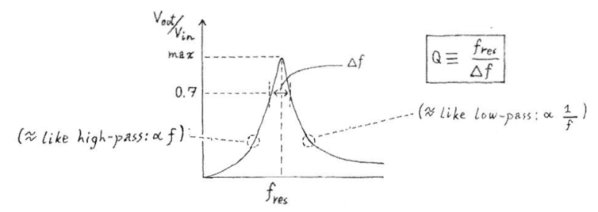
Here $Δf$ is the width at the amplitude that delivers half-power—the amplitude that is $3$dB below the peak.
The $RLC$ does not work the way an $RC$ filter does. It is more dynamic and does more than form a frequency-selective voltage divider, although it does do that. It stores energy; it is more like a pendulum than like a coffee filter. The inductor capacitor combination oscillates, once stimulated with a frequency close to its favorite—the frequency where it "resonates." In each cycle of oscillation, energy is transferred, back and forth, between inductor and capacitor.
When the voltage across the parallel pair is at a maximum, energy is stored in the electrostatic field between the plates of the capacitor; as the capacitor begins to discharge through the inductor, the current gradually grows, and when the current reaches a maximum, $V_{CAP}$ is zero. At that point in the cycle, all the circuit's energy is stored in the magnetic field around the inductor. The energy sloshes back and forth between capacitor and inductor.
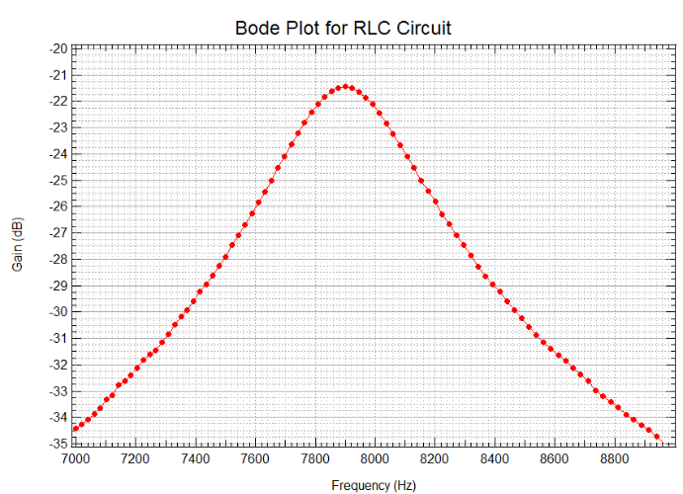
Estimate the $Q$ factor for the circuit whose Bode plot is shown above. Enter your result and explanation on the following page.
Click or tap here to enter text.

Fourier Components of a Square Wave
Recall that the Fourier series expansion of a square wave can be expressed as
$$\frac{4A}{π}\left[\sin\left(2πf_{0}t\right)+\frac{1}{3}\sin\left(2π⋅3f_{0}t\right)+\frac{1}{5}\sin\left(2π⋅5f_{0}t\right)+ ⋅⋅⋅ \right]$$
where $f_{0}$ is the fundamental frequency and $A$ is the amplitude of the square wave. The image below on the left shows the first three terms in this series (with $A=1$) and the one on the right shows these terms added together and a square wave (dotted line) for reference.
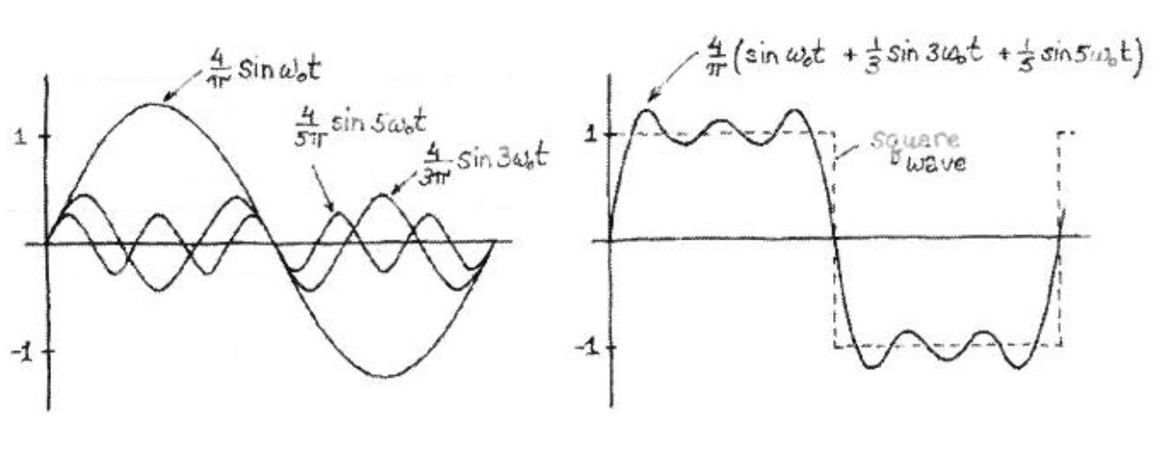
The circuit from problem 1 can be used as a frequency detector. If the input signal has a frequency component that matches the resonant frequency of the circuit then the output will be large. In the lab you will verify this by applying a square wave at the resonant frequency to the input of the circuit in Problem 1. You will observe a sine wave of the same frequency. The circuit will pass only the fundamental frequency component of the square wave.
Suppose you reduce the frequency of the square wave slowly. At what other frequencies will you see a large output from the circuit? What will be the amplitudes of these signals in relation to the amplitude when you applied a square wave of the resonant frequency?
Click or tap here to enter text.

