Name:  Click or tap here to enter text. | Date:  Click or tap to enter a date.

LED Biasing
The four circuits below each consist of a DC voltage source, a resistor, and a LED arranged in different geometries.

Forward Biased LEDs
In which of the circuits below is the LED forward-biased which will result in the LED shining? Check the boxes below for all that are forward-biased.

Match Circuit and 3D Image
For each of the 3D images below, select the number of the above circuit that matches the image.
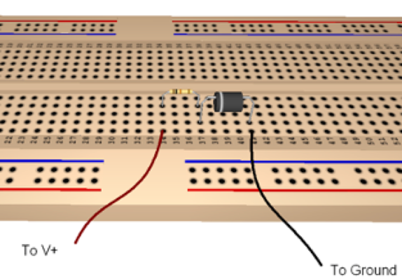 | 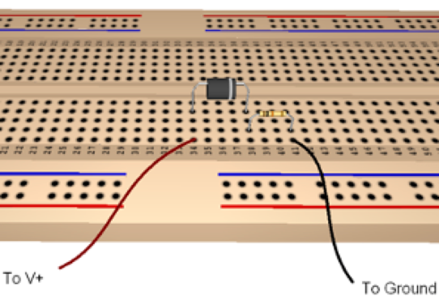
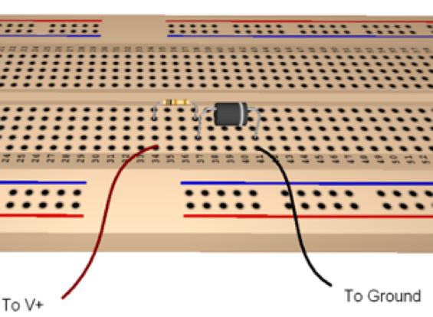 | 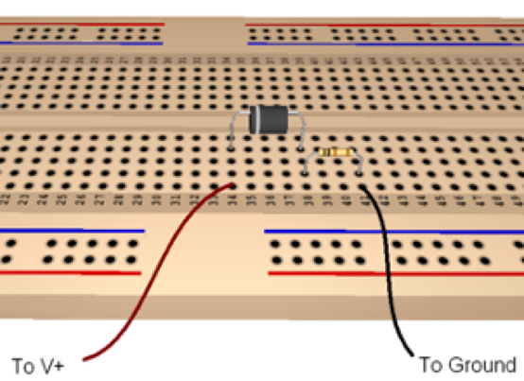

Current-Limiting Resistor
When using a light-emitting diode in a circuit one always should provide a means to control the maximum current that could possibly pass thru the diode. This is most often done with a series resistor whose value is chosen to limit the current. Consider a simple circuit consisting of a resistor $R$ in series with an LED whose forward voltage is 1.85V. Suppose the input to the circuit is a digital output that can be activated to provide 5 volts when turned on. Compute the series resistance $R$ that will limit the current thru the diode when activated to 20 mA and then select from the available 5% resistors that is nearest this value. Describe your computation and how you select the resistance $R$ below.

Select the Current Limiting Resistance
Click or tap here to enter text.

I-V Curve for Diode
The circuit below can be used to measure the $I$-$V$ curve for a diode.
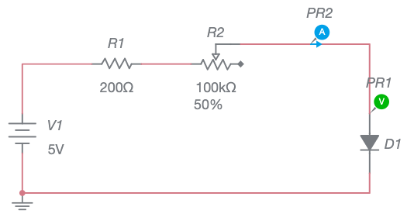
In this circuit the $200Ω$ resistor is designed to limit the current to a maximum safe value and the $1kΩ$ potentiometer can be adjusted to change the current thru and voltage across the diode. This circuit was built using MultiSim Live which we will often use to simulate real circuits. Unfortunately, this online version of MultiSim does not support adding realistic meters such as ammeters (in series) and voltmeters (in parallel) to a circuit. Instead, it uses what are called probes to measure the current or voltage at any specific point in the circuit. The current probe $PR2$ measures the current thru the diode and the voltage probe $PR1$ measures the voltage at a point above the diode relative to ground. In this case, this is the same as the voltage across the diode.
To use this circuit for this exercise, click the following link and then click on a button named Open Circuit.
https://www.multisim.com/content/hgTcwDRddhyRrNk26PVyFb/diode-characterization/
The circuit will open in MultiSim Live and you can run the simulation by pressing the white triangle labeled as the Run Button in the image below. The current and voltage values will be shown in the probes. If you click on the potentiometer percentage a slider will appear as shown below.
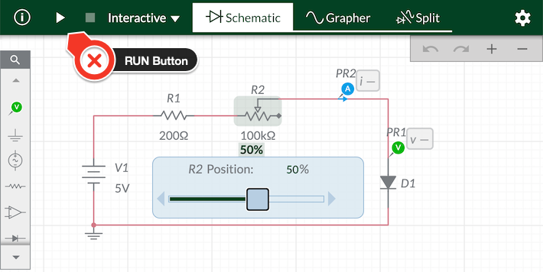
As you adjust the slider you should notice the current and voltage values changing. Determine the maximum and minimum voltage values and collect 10 to 12 measurements approximately equally spaced in voltage over this range. Record these values in your favorite graphing application and produce a properly labeled graph of current versus voltage. Save an image of your graph and upload it below.

I-V Curve for Diode


