Name:  Click or tap here to enter text. | Date:  Click or tap to enter a date.

Non-Inverting Amplifier

Apply golden rules to find gain.
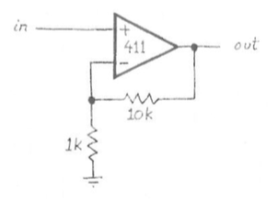
Consider the adjacent non-inverting amplifier. You will recognize this as nearly the follower except that we are tricking the op-amp into giving us an output bigger than the input.
As a thought experiment, consider applying 1V to the non-inverting input $(+)$. If you apply the op-amp golden rules you understand neither input draws any current and the op-amp will do whatever it can to keep the potential at each input terminal the same. As a result, the voltage at the inverting input $(-)$ will also be 1V. Thus, the two resistors form a voltage divider with the voltage at the midpoint of the two resistors being 1V. What must the voltage at the top of the divider, the output of the op-amp, be to maintain 1V at the inverting input? Thus, what is the voltage gain of this circuit? Does this agree with the formula you’ve seen in the pre-lab for the gain of a non-inverting amplifier?
Click or tap here to enter text.

Build the non-inverting amplifier
Wire up the non-inverting amplifier shown above. Don’t forget to apply power to the $+V_{cc}$ and $-V_{cc}$ inputs. Apply a $1 V_{pp}$, $1$ kHz sine wave to the input and measure the output. Capture an oscilloscope trace that shows both the input and output signals and show it on the following page.
Measure the gain of the circuit. Does the gain you observe agree with what you would expect for this circuit?
Click or tap here to enter text.

Oscilloscope trace for non-inverting amplifier



Maximum output swing
Increase the amplitude of the circuit and observe if the gain stays constant. Describe what happens to the output signal eventually if you increase the input amplitude high enough. What are the maximum output values (both positive and negative) that you can observe?
Click or tap here to enter text.

Frequency response
Return the amplitude of the input signal to a reasonable value and begin investigating what happens to the output as you increase the frequency of the input. Jump up in frequency a decade at a time until you start noticing the output of the circuit showing departures from what you would expect from the ideal op-amp model. Find a frequency that shows a definite degradation in the output. Capture an oscilloscope trace (next page) of the input and output and describe your findings below.
Click or tap here to enter text.

Gain-Bandwidth Product

Build adjustable-gain, non-inverting amplifier.
Create an adjustable-gain, non-inverting amplifier by changing the feedback resistor in your non-inverting amplifier from the original $10kΩ$ resistor to a $1kΩ$ in series with a $100kΩ$ potentiometer with one side open as shown below. Be sure you are using the LM741 amplifier as it has a lowest gain-bandwidth product (1 MHz) of the amplifiers in our lab. Also add a $1kΩ$ load resistor so the amplifier has to do a little work (more than just driving the high impedance scope).
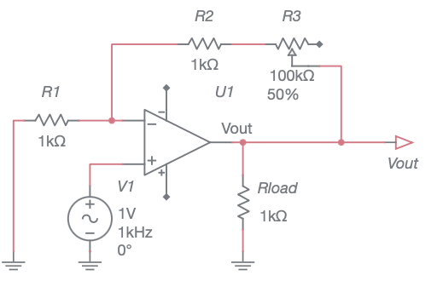
Adjust the potentiometer so that your amplifier has a gain of 64 (~ 36 dB). Measure the input and output on the oscilloscope to verify you have the proper gain.

Find cutoff frequency
Measure the cutoff frequency of the amplifier at this gain setting using the Bode Analyzer. Show the Bode plot below.

Gain dependance of cutoff frequency
Repeat the above measurements for gains of 32, 16, 8, 4, and 2. Report your results in the table below. Compute the gain-bandwidth product (GBW = gain$⋅$bandwidth) for each setting. Comment on your results in the box following the table.
Gain $\frac{V_{out}}{V_{in}}$ | Cutoff Frequency, $f_{-3 dB}$ (Hz) | $$G⋅BW$$
2 | Click or tap here to enter text. | Click or tap here to enter text.
4 | Click or tap here to enter text. | Click or tap here to enter text.
8 | Click or tap here to enter text. | Click or tap here to enter text.
16 | Click or tap here to enter text. | Click or tap here to enter text.
32 | Click or tap here to enter text. | Click or tap here to enter text.
64 | Click or tap here to enter text. | Click or tap here to enter text.
Comment on the measured GBW vs the nominal value of 1 MHz for the 741 op-amp.
Click or tap here to enter text.

Gain Bandwidth product for LF356
Attempt the same measurements with the LF356. Start at high gain values and at some point you will likely run up on the limitation of our equipment which will not be able to go high enough in frequency to find the cutoff frequency. The typical GBW for the LF356 is 5 MHz.
Gain $\frac{V_{out}}{V_{in}}$ | Cutoff Frequency, $f_{-3 dB}$ (Hz) | $$G⋅BW$$
2 | Click or tap here to enter text. | Click or tap here to enter text.
4 | Click or tap here to enter text. | Click or tap here to enter text.
8 | Click or tap here to enter text. | Click or tap here to enter text.
16 | Click or tap here to enter text. | Click or tap here to enter text.
32 | Click or tap here to enter text. | Click or tap here to enter text.
64 | Click or tap here to enter text. | Click or tap here to enter text.
Comment on the measured GBW vs the nominal value of 1 MHz for the 356 op-amp.
Click or tap here to enter text.

Inverting Amplifier

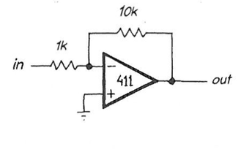
Apply golden rules to find the gain
Consider the adjacent inverting amplifier circuit.
Again, think about applying a 1V signal to the input and use the golden rules to argue what the value of the output signal will be. Along the way, you should mention what the potential will be at the non-inverting input, what the current will be through the 1k resistor and through the 10k feedback resistor in your argument.
Click or tap here to enter text.

Build the inverting amplifier
Construct the inverting amplifier shown above. If you are sly, you will notice that you don't need to start fresh. You can use the previous non-inverting amplifier, simply redefining which terminal is input, and which is grounded. Apply a $1 V_{pp}$, $1$ kHz sine wave to the input and measure the output to compute the gain of the circuit.
Capture an oscilloscope trace that shows the input to and output from the circuit.

Compare the measured and predicted gain for this circuit.
Click or tap here to enter text.

Measure input impedance
Measure the input impedance of this circuit by adding $1kΩ$ resistor in series with the signal source (simulating a source of crummy $R_{out}$).
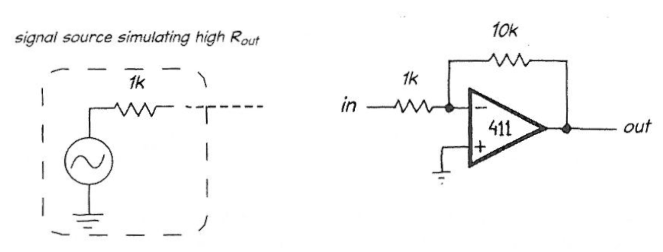
If you suppose that the $1kΩ$ resistor in series with your signal source represents the output impedance for your source, then what is the inverting amp’s gain for such a source?
Click or tap here to enter text.

Use a voltage follower to solve poor $R_{out}$.
Take advantage of a voltage follower, to solve the problem that we have created for you, the signal source’s poor $R_{out}$. With the follower’s help. your inverting amp’s overall gain should jump back up to its original value of $-10$.
Capture an oscilloscope trace that shows the input to and output from the circuit with the isolation provided by the follower.

Describe how the follower allows you to get the full gain from the amplifier circuit.
Click or tap here to enter text.

