Name:  Click or tap here to enter text. | Date:  Click or tap to enter a date.

Operational Amplifiers
Package: We will use operational amplifiers in an 8-pin mini-DIP (dual in-line package) housing.
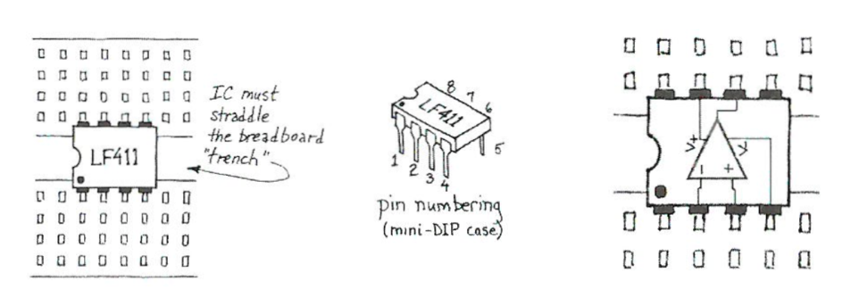
The pinout (best represented in the rightmost image) was established by op-amps long ago and is standard for single op-amps in this package. Such standardization is kind to all of us users. Unfortunately, as parts get smaller, DIP parts are becoming scarce. Many new designs are issued in surface-mount packages only.
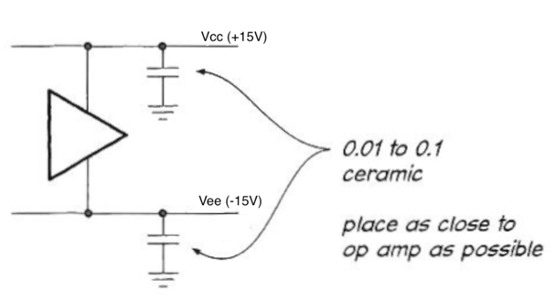
Power: A point that may seem to go without saying, but sometimes needs a mention: the op-amp always needs power, applied at two pins sometimes labeled $V_{cc}$ (pin 7) and $V_{ee}$ (pin 4) for the positive and negative supplies respectively. In the diagram above they are labeled $V_{+}$ and $V_{-}$ rather confusingly as those are the terms that are also sometimes used for the non-inverting (pin 3) and inverting (pin 2) inputs. We will nearly always use the ±15V built in supplies for powering the amplifier. We remind you of this because circuit diagrams ordinarily omit the power connections. On the other hand, many op-amp circuits make no direct connection between the chip and ground. Don't let that rattle you: the circuit always includes a ground in the important sense: a common reference treated as $0$V.
Decoupling: You should always “decouple” the power supplies with a small ceramic capacitor (0.01 - 0.1 µF), as suggested in the adjacent figure. If you begin to see fuzz on your circuit outputs, check whether you have forgotten to decouple. Most students don't believe in decoupling until they see that fuzz for the first time. Op-amp circuits, using feedback in all cases, are peculiarly vulnerable to such “parasitic oscillations”.

Open-loop test circuit.
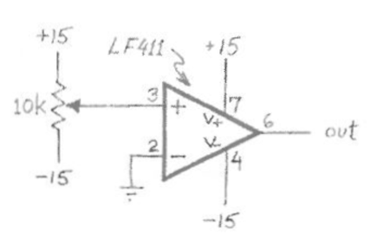
Astound yourself by watching the output voltage on the oscilloscope as you slowly twiddle the potentiometer in the adjacent circuit.
When the output of an op-amp goes to (nearly) the value of one of the power supplies (+15V or -15V) we say that the output has saturated. See if you can apply an input voltage that will keep the output from saturating. Is the behavior consistent with the 411 specification that claims “Gain (typical), 200V/mV”? Don't spend long “astounding yourself” however; this is a most abnormal way to use an op-amp. Hurry on to the useful circuits!
Describe the open-loop behavior of the op-amp below. What happens when your input switches from a positive value to a negative value? Can you obtain an output that is linear with the input?
Click or tap here to enter text.

Voltage Follower

Unloaded and Loaded Voltage Divider
Build the unloaded and then the loaded voltage dividers that were mentioned in the pre-lab exercise and shown again below. For the divider use $R=100kΩ$ and use a $1kΩ$ load. Use the variable power supply to create the +10V source.
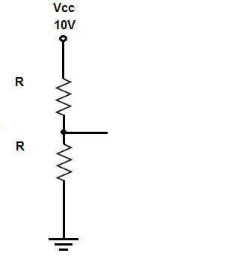 | 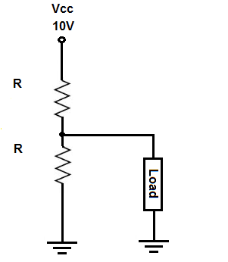
Unloaded Voltage Divider | Loaded Voltage Divider
Use the DMM (or scope if you prefer) to measure the output of each and describe your findings below.
Click or tap here to enter text.

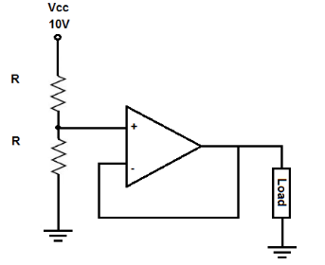
Buffered divider with a voltage follower
Now build a voltage follower and use it to connect between the output of the bare divider and the $1kΩ$ load as shown.
Predict and measure the output of this circuit and report your results below. Also, comment on what your observations say about the input impedance of the voltage follower.

Click or tap here to enter text.

Golden rules of an op-amp
In the pre-lab you saw discussion of a simple, idealized view of the op-amp, described by infinite input impedance, zero output impedance, very large open-loop gain, and infinite bandwidth. We can summarize this behavior in what are often called the golden rules of an op-amp. Keep in mind that the golden rules (below) are approximations, but good ones.
1. The output tries to do whatever is necessary to make the voltage difference between the two inputs zero.
2. The inputs draw no current.
Three observations, before we start applying these rules:
- In rule 2, be sure you understand that the “inputs” that draw no current are the signal inputs, not the op-amp’s power supply terminals!
- In rule 1, the word “tries” is important. It reminds us that it’s up to us, the circuit designers, to make sure that the op-amp can hold its two inputs at equal voltages. If we blunder—say, by overdriving a circuit—we can make it impossible for the op-amp to do what it “tries” to do.
- It is also important to remember that these rules apply only to op-amp circuits that use negative feedback.
Describe the behavior you observed for the buffer circuit in the previous step using the language of the golden rules for an op-amp.
Click or tap here to enter text.

Output impedance
Recall we emphasized in the pre-lab that the output impedance of an op-amp is “low”. Technically the output impedance of the bare op-amp is usually on the order of $100Ω$, but it is difficult to measure. Rather than ask you to measure it, we propose to let you show yourself that it is feedback that is producing the extremely low output impedance we observe.
Add a $1kΩ$ resistor in series with the output of the follower; treat this (perversely) as a part of the follower and look at $V_{out}$ with and without load attached. This is our usual procedure for testing output impedance. There should be no surprises here. $R_{out}$ had better be $1kΩ$. Show this with a computation below.
Now move the feedback point from the op-amp's output to the point beyond the $1kΩ$ series resistor— to apply "feedback #2," in the figure. What's the new $R_{out}$? How does this work?
Click or tap here to enter text.

Response to a sine wave input
Change the source from the +10V provided by the variable power supply to the function generator. Create a 1kHz sine wave and apply it to the input of the voltage divider. Set the peak-to-peak amplitude to +10V. This should create a sine wave with a peak-to-peak amplitude of +5V at the output of the voltage divider and the input to the voltage follower. Measure both the input to the follower and the output from it on the oscilloscope and show the results below.


Measure the response to a step input.
In a truly ideal op-amp, with infinite gain and bandwidth and slew rate, the process described in the ideal model happens instantaneously.
In the real world, op-amps have a finite gain-bandwidth product, so the intuitive model process happens more literally over a finite period of time.
Create a square wave with as high a frequency as you can generate and measure on your system. Again measure the input to and the output from the voltage follower.

Can you observe any evidence that the response of the op-amp is not perfect at high frequencies?
Click or tap here to enter text.

Measure the response to a step input
As you may be unable to reach a high enough frequency to see the limitation of the op-amp you are using, consider the following simulation at https://www.circuitlab.com/editor/v9xf6jpa325g/. After opening the simulation click the Simulate button at the bottom and then click Run Time Domain Simulation.
This simulation uses an op-amp that has finite gain-bandwidth product of 1 GHz, and passes in a 100 MHz square wave input signal. Paste an image of your simulation below (next page) and comment on how long it takes the output to respond after the input changes.
Click or tap here to enter text.

Measure frequency response with Bode plotter
With an ideal op-amp, the voltage buffer would have a perfectly flat frequency response, with a gain of 1 out to unlimited frequency.
In a real-world op-amp with a finite gain-bandwidth product, the voltage buffer configuration has a closed-loop gain of 1, so the bandwidth is equal to the gain-bandwidth product.
Use the ELVISmx Bode plotter to attempt to measure the frequency response of your voltage follower. Measure to as high frequency as is possible with your system.

Simulate the frequency response
Try this simulation (https://www.circuitlab.com/editor/t47w8u2tanx5/) with a 10 MHz GBW op-amp and observe that the gain is flat until reaching a corner at 10 MHz.
Click to open and simulate the circuit above. What’s the -3 dB frequency? Double-click $OA1$, adjust the open loop gain $A_{OL}$, and re-run the simulation: does the Bode plot change? Next, do the same for GBW.
Click or tap here to enter text.

As shown by this circuit simulation, the -3 dB knee in the frequency response curve happens at the gain-bandwidth product (GBW) of the op-amp.
For practical purposes, this means that we can assume that a real-world op-amp voltage buffer will do its job well for signals with a frequency much lower than the GBW of the op-amp. As a rule of thumb, let’s say you’re reasonably safe if
$$f_{signal}<\frac{1}{10}GBW.$$
For signals at frequencies at or above the GBW, the op-amp won’t be able to respond fast enough to copy the signal from input to output. The GBW is listed on an op-amp’s datasheet, so you may be able to solve this problem by simply buying a faster op-amp.

