Name:  Click or tap here to enter text. | Date:  Click or tap to enter a date.

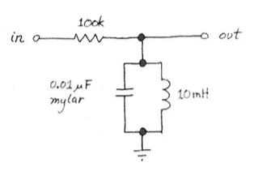
Response to Sinusoidal Input
Construct the parallel resonant circuit shown. Drive it with a 10V_{pp} sinewave, varying the frequency through a range that includes what you calculate to be the circuit’s resonant frequency. Compare the resonant frequency that you observe with the one you calculated in the prelab. (The circuit attenuates the signal considerably, even at its resonant frequency; the $L$ is not perfectly efficient, but instead includes some series resistance.) As you watch for resonance, don’t look for the frequency that delivers maximum amplitude out (this is difficult to determine), but instead watch for the other signature of resonance: the frequency where output is in phase with input.

Resonance frequency.
Create an oscilloscope trace that shows both the input to the circuit and the output of the filter for the situation where the filter is in resonance. Choose vertical scaling such that the traces nearly fill the vertical space and a horizontal scaling such that there are a couple of cycles of the waveforms visible.


Measured resonance frequency.
Compare the resonance frequency you observed with the value you predicted in the prelab?
Click or tap here to enter text.

Describe the off-resonance behavior.
Describe the behavior of the output (both the amplitude and phase) both for frequencies below resonance and above resonance. Be specific about whether the output leads or lags the input in each case.
Click or tap here to enter text.

Estimate the $Q$: Quality Factor.
Estimate the circuit’s $Q$ or “quality factor”, defined as
$$Q=\frac{f_{r}}{Δf} ,$$
where $Δf$ represents the width of the resonance peak between its “half-power” or -3dB points. The skinnier the peak, the higher the $Q$.
You can make a very good measurement of $Q$ by adjusting the input to find the frequencies, below and above resonance, where output amplitude is down 3dB. Note that this is “down 3dB” relative not to amplitude in but relative to the maximum amplitude out, or the amplitude at resonance. The amplitude out never equals amplitude in, which it would only if our components were perfect.

Find the half-power frequency below resonance.
Show an oscilloscope trace that identifies the frequency below resonance at which the amplitude of the output is reduced by -3dB from its peak value at resonance.
Explain how you decided upon this frequency.
Click or tap here to enter text.

Find the half-power frequency above resonance.
Show an oscilloscope trace that identifies the frequency above resonance at which the amplitude of the output is reduced by -3dB from its peak value at resonance.

Explain how you decided upon this frequency.
Click or tap here to enter text.

Compute the $Q$ factor.
Combine your previous results to compute the $Q$ for this circuit.
Click or tap here to enter text.

Effect of lower resistance.
Investigate the effect on $Q$ of substituting a $10kΩ$ resistor for the $100kΩ$. You’ll notice that the amplitude out increases, with this reduced $R$. The fraction that survives, $V_{OUT}/V_{IN}$, grows. But as amplitude out grows, $Q$ degrades. As is often the case, you’re obliged to trade away one desirable trait to get another. Good $Q$, however, is likely to be much more important than large amplitude; an amplifier can solve the problem of low amplitude.
For the particular $RLC$ circuit we are using with the parallel combination of $LC$ one can show that the $Q$ can be expressed as $Q=ω_{r}RC=2πf_{r}RC$. While it is not likely that you will obtain great agreement with this result due to imperfections of the inductor, it is useful for showing how the $Q$ factor scales with resistance.
Describe the changes in the filter characteristics when you change the resistance from $100kΩ$ to $10kΩ$.
Click or tap here to enter text.

Bode Plots
To reinforce what you have observed for this filter at frequencies below, at, and above resonance, set up the ELVIS II to perform a Bode Analyzer plot. Set the starting frequency, ending frequency, and number of steps per decade to zoom in on the area around the resonance extending somewhat past the half-power points on each side. Your frequency range may be much less than a decade and you may have to set a quite large number of points per decade to obtain good resolution on the final plot.
Bode Plot with $R=100kΩ$ | Bode Plot with $R=10kΩ$

Find the Fourier Components of a Square Wave
The equation and figures below show the first few frequency components in the Fourier series for a square wave. You met this series earlier in the prelab exercise.
$$\frac{4A}{π}\left[\sin\left(2πf_{0}t\right)+\frac{1}{3}\sin\left(2π⋅3f_{0}t\right)+\frac{1}{5}\sin\left(2π⋅5f_{0}t\right)+ ⋅⋅⋅ \right]$$
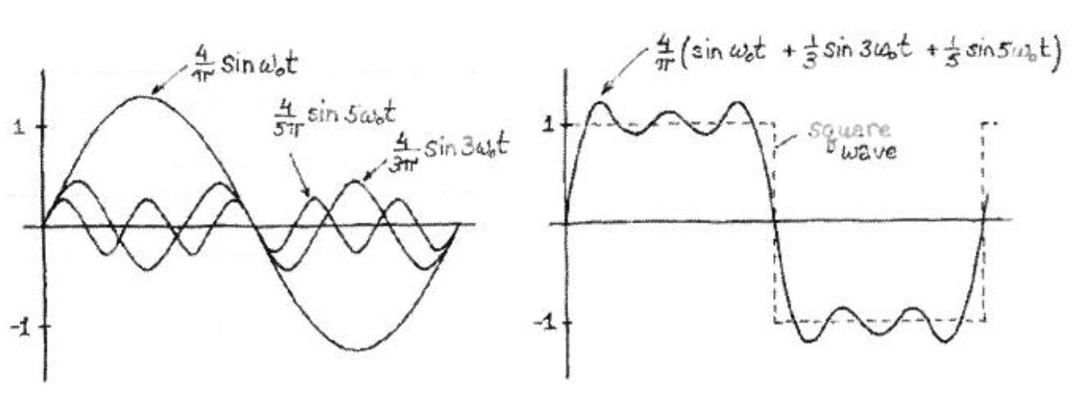
The $RLC$ resonant circuit can serve as a “Fourier Analyzer” to pick out these frequencies, since the circuit’s response measures the amount of 16kHz (approx.) present in an input waveform.
First, be sure to return the 100k resistor that provides the sharper bandpass response.
Then, try driving the circuit with a square wave at the resonant frequency; note the amplitude of the (sinewave) response. Now gradually lower the driving frequency until you get another peak response (it should occur at approximately 1/3 the resonant frequency) and check the amplitude (it should be approximately 1/3 the amplitude of the fundamental response). With some care you can verify the amplitude and frequency of the first several terms of the Fourier series.
See how many terms you can identify and summarize your findings in the table below and show some of the oscilloscope traces in the spaces provided on the following page.
Frequency (Hz) | $$f_{i}/f_{r}$$ | Amplitude (V) | $$A_{i}/A_{r}$$
 | 1.0 |  | 1.0

Ringing
Now try driving the circuit with a low-frequency square wave. Try 20Hz, but note that any low frequency will do; what matters is the steep edge of the waveform with its high-frequency components. If you prefer, think of the edge as putting a jolt of energy into the resonant circuit, energy that sloshes back and forth between $L$ and $C$ until it has been dissipated. You should see a brief output in response to each edge of the input square wave. If you look closely at this output, you can see that it is a decaying sinewave.

Oscilloscope trace showing ringing
Capture an oscilloscope trace showing the input square wave and the output which decaying sine wave that displays the ringing that occurs when the circuit is hit with the edge of the square wave input (upload it on the following page). What is the frequency of this sinewave? (No surprise, here.). Does the amplitude of the sine wave appear to decay exponentially?
Click or tap here to enter text.

Estimating $Q$ from decay envelope
One can also evaluate $Q$ by noticing how fast the oscillation envelope decays away, after a stimulus to the $RLC$. The $Q$ can be defined in terms of how slowly energy leaks away from a resonant circuit, dissipated in its stray resistance using the formula
$$Q=ω_{r}\frac{energy stored}{average power dissipated}.$$
This can be shown to reduce to
$$Q=2π⋅N_{decay},$$
where $N_{decay}$ is the number of cycles required for the energy to diminish to 1/e (or 37%) of its initial value. Since the energy is proportional to $V^{2}$, we will need to look for where the voltage has dropped to $≈1/\sqrt{e}≈60\%$ of its initial value.
When you see your own circuit's response to the slow square wave, count the cycles before decay to about 60%, and see if your $Q$, so calculated, matches the value previously in section 2.3.
Click or tap here to enter text.

