Name:  Click or tap here to enter text. | Date:  Click or tap to enter a date.

Gather and Measure Components
In this introductory activity you will build some basic circuits and make some basic measurements to become familiar with using the equipment in the laboratory.
Obtain the following components from storage and measure their component values both with the handheld digital multimeter and the ELVISmx Digital Multimeter soft front panel. Record your results in the table below. You should not expect the measured component values to match exactly the nominal values as the resistors have a tolerance of $±5\%$ and the capacitor has a tolerance of $±10\%$.
- 1 kΩ resistor, R1, (brown, black, red)
- 2 kΩ resistor, R2, (red, black, red)
- 1 MΩ resistor, R3, (brown, black, green)
- 1 μF capacitor, C
Component | Nominal Value | Handheld DMM | ELIVSmx DMM
$$R_{1}$$ | $$1.0 kΩ$$
$$R_{2}$$ | $$2.0 kΩ$$
$$R_{3}$$ | $$1.0 MΩ$$
$$C$$ | $$1.0 μF$$

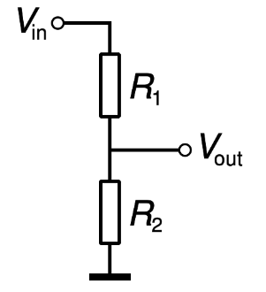
Voltage Divider
A voltage divider is a very common circuit that consists of two resistors in series where a voltage is applied across the pair of resistors and the output is measured across only one resistor as shown. You can analyze this circuit easily using only Ohm’s Law. First, find the equivalent resistance of the entire circuit and use Ohm’s Law with the total input voltage to estimate the current in the circuit. Then, using that current, apply Ohm’s Law to $R_{2}$ to find the output voltage.

Predict the output of voltage divider
Assuming an input voltage of $V_{in}=5V$ and the resistors $R_{1}$ and $R_{2}$ have the nominal values from above, predict the total equivalent resistance of the circuit, the current thru the circuit, and the output voltage measured across $R_{2}$ as shown above. Discuss your result below.
Click or tap here to enter text.

Measure the output voltage of the divider.
Build the voltage divider as shown below on the NI ELVIS II+ breadboard.
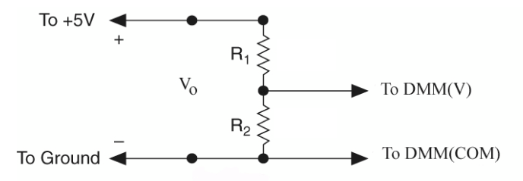
Measure the output voltage from the divider and compare it to your predicted value.
Click or tap here to enter text.

Measure the current thru the divider.
Recall that to measure current the ammeter must be placed in series with the circuit. In this case we must break a connection in the circuit to insert the ammeter. Rearrange the circuit as shown below so that you can use the ELVIS DMM to measure current.

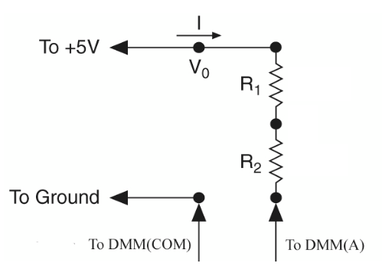
Measure and record the current thru the voltage divider and compare it to your predicted value.
Click or tap here to enter text.

RC Circuit
If we change the output resistor in a voltage divider to a capacitor, we obtain a basic $RC$ circuit. We will study this circuit in more detail later, but for now we show that as power is turned on or off to this circuit the voltage across the capacitor will charge or discharge with a characteristic time that is described by a time constant $τ=RC$. As a rule of thumb, we will see that the capacitor will be nearly fully charged (or fully discharged) about 5 time constants after the voltage is turned on (or off).

RC circuit with long time constant.
Build the circuit shown below with the $1MΩ$ resistor and $1μC$ capacitor.
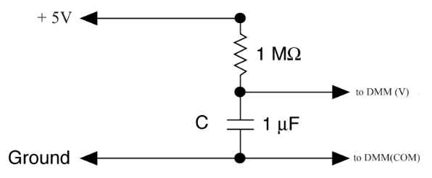
Observe the behavior of the voltage on the DMM as you power on the circuit. Wait for the voltage to reach a steady state. Also power off the circuit and watch the voltage across the capacitor exponentially decrease to 0 V as it discharges. Describe what you observe including approximately how long it takes the capacitor to charge and discharge. Compare this value to the time constant $τ=RC$ of the circuit.
Click or tap here to enter text.

Observe an RC circuit on the oscilloscope.
Make the following modifications to the previous RC circuit.
- First, change the 1 MΩ resistor to 1 kΩ. This will reduce the time constant of the circuit by a factor of $1000$ requiring the use of an oscilloscope to view the increasing and decreasing capacitor voltage.
- Route the output voltage across the capacitor to the one of the SCOPE inputs so it can be observed on the Digital Oscilloscope soft front panel instead of on the DMM.
- We will want to be able to quickly turn on and off the source voltage so change the input to the circuit from the $+5V$ supply to the Function Generator. To monitor this input voltage, set up an additional oscilloscope channel to measure the function generator output.
- Power the circuit with a 0 to 4V square wave with a frequency of 100 Hz from the function generator. You will need to adjust the Amplitude and DC offset controls on the function generator to get the desired 0 to 4V signal.
Capture an oscilloscope trace that shows a couple of cycles of the capacitor charging and discharging. Your trace should show both the input to the circuit and the output voltage across the capacitor.


Compute the $RC$ time constant.
What is the value of the time constant of this new circuit with the $1kΩ$ resistor and $1μC$ capacitor?
Click or tap here to enter text.

Measure the $RC$ time constant.
We will learn that the voltage across the capacitor during charging and discharging cycles will be given by:
$V_{charging}=V_{0}(1-e^{-t/RC})$ $V_{discharging}=V_{0}e^{-t/RC}$
After one time constant $t=τ=RC$, these relations have values of $V_{c}\left(τ\right)=V_{0}\left(1-e^{-1}\right)=0.63V_{0}$and $V_{d}\left(τ\right)=V_{0}e^{-1}=0.37V_{0}$respectively. In one time constant, the capacitor will charge to 63% of its maximum value in one or will discharge to 37% of its maximum value as shown in the image below.
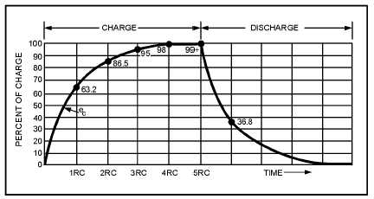
Adjust the oscilloscope to trigger on a rising edge of the source voltage and adjust the time per division so that you zoom in on a region where the capacitor is charging. Use the cursors to measure the amount of time required for the capacitor to charge from $0V$ to $0.63\%$ of the full source voltage. This time is your estimate for the time constant $τ$ of the circuit. Ask for help is this is the first time using triggering and cursors with the oscilloscope.
Capture an image of the oscilloscope display showing the cursor readout in the position you used to estimate the time constant.
State the result you obtained from the oscilloscope for your estimate of the $RC$ time constant and compare this result to the predicted value you computed earlier using the values of $R$ and $C$ for your circuit.
Click or tap here to enter text.

