Name:  Click or tap here to enter text. | Date:  Click or tap to enter a date.

Design, Build and Test a Simple Band Stop Filter

Rules
You may use your notes and previous work from the laboratory course, but you may not search the internet for information. You may ask the instructor questions for clarification, but you should not discuss the question with others in the class.

Background
In this exercise you are asked to create a band-stop filter by piecing together circuit elements that you have previously studied. The desired frequency response of this filter is shown below.
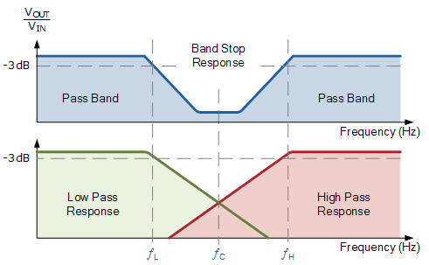
Frequencies below a low-frequency cutoff $f_{L}$ and above a high frequency cutoff $f_{H}$ should be passed through the circuit unattenuated. There should be a “stop band” of width $BW = f_{H}–f_{L}$ centered at a frequency
$$f_{C}=\sqrt{f_{L}f_{H}}$$

where signals are attenuated by the circuit. The quality factor, $Q$, of this circuit is defined as
$$Q=\frac{f_{C}}{BW}$$

This type of circuit cannot be constructed by using a low-pass filter in series with a high-pass filter. Hopefully the reason is obvious to you. If not, think about it for a minute and you will realize that if you place the filters in series then the first one will cut out desirable frequencies that the second one means to keep. Instead, to create the band-stop filter in this fashion by combining a low-pass and high-pass filter, one needs to split the signal and use a parallel arrangement of the two filters and then sum the results back together as depicted below.
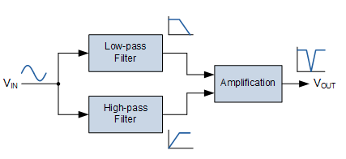

Exercise
Design a basic wide-band, $RC$ based band-stop filter with a low cut-off frequency of $f_{L}=200$Hz and a high cut-off frequency of $f_{H}=800$Hz. This can be easily implemented using separate passive $RC$low-pass and high-pass filter circuits isolated from each other by non-inverting voltage followers, (Gain = 1). The output from these two filter circuits should then be summed using a third operational amplifier connected as a summing amplifier.

Center Frequency and Quality Factor
Compute the expected center frequency $f_{c}$ AND expected quality factor $Q$ for this filter where the low cutoff frequency is $f_{L}=200$ Hz and the high cutoff frequency is $f_{H}=800$ Hz.
Click or tap here to enter text.

Resistors for Filters
Using capacitor values of 0.1 µF for each of the capacitors on your filter circuits, determine the appropriate resistor value for each filter to create the desired cutoff frequencies. Describe and justify your resistor choices below.
Click or tap here to enter text.

Circuit Sketch
Sketch the circuit that you plan to build. Label component values on your diagram. The input voltage from the function generator should split and go into separate low-pass and high-pass filter circuits. Each of these filters should be followed by a unity-gain buffer (voltage follower). Finally, the outputs of these two sub-circuits should be combined using a (unity gain) summing amplifier. The summing amplifier will invert the signals (gain=-1) but we don’t particularly care about that as our focus is on the overall frequency dependence.
Yes, this means your circuit should include three amplifier chips, two for the voltage followers and one for the summing amplifier. Take a picture of your circuit sketch and upload it below.


Build and Test the Circuit
Build the circuit that you designed. While debugging your circuit, you should test each filter independently to ensure that it is behaving the way that you expect. In other words, test the frequency response of the low pass filter alone, then test the high pass filter alone, then test each filter with its corresponding voltage follower, and finally test the full circuit consisting of the filters, followers, and summing amplifier.
When the overall circuit is working, take oscilloscope screen captures showing both the input and output signals from your completed circuit using sine wave inputs of frequencies $0.1f_{L}$, $0.5f_{L}$, $f_{L}$, $f_{C}$, $f_{H}$, $2f_{H}$, and $10f_{H}$, manually measure the gain at each of these frequencies, and describe the results that you observe.

$$f=0.1f_{L}=20 Hz$$ | $$f=0.5f_{L}=100 Hz$$
$$f=f_{L}=200 Hz$$ | $$f=f_{C}=________ Hz$$
$$f=f_{H}=800 Hz$$ | $$f={2f}_{H}=1,600 Hz$$

$$f={10f}_{H}=8,000 Hz$$

Frequency (Hz) | $$V_{IN} (Hz)$$ | $$V_{OUT} (Hz)$$ | $$Gain=V_{OUT}/V_{IN}$$ | Gain (dB)
$$0.1f_{L}=20$$
$$0.5f_{L}=100$$
$$f_{L}=200$$
$$f_{C}$$
$$f_{H}=800$$
$$2f_{H}=1,600$$
$$10f_{H}=8,000$$
Comment on how your measurements at different frequencies agree (or disagree) with your expectations.
Click or tap here to enter text.

Bode Analyzer Plot
Characterize the frequency response of your circuit from 10Hz to 10kHz by using a Bode analyzer.

Bode plot analysis
Use your Bode plot to find the actual -3dB low- and high-frequency cutoff values, bandwidth, center frequency, and $Q$ value and compare these to the values you expected.
Click or tap here to enter text.

